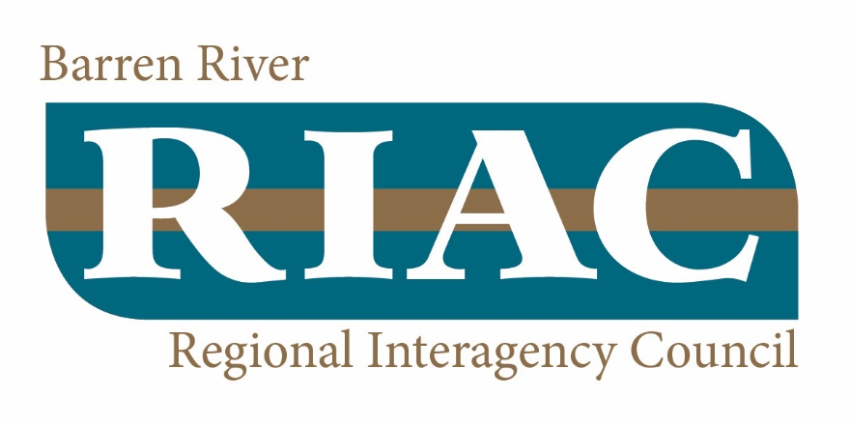
Agency | Name | Phone | Email
RIAC Leaders
Local Resource Coordinator (LRC - LifeSkills) | Anne Embry | (270) 901-5251 | aembry@lifeskills.com
RIAC Chair (Department for Community Based Services) | Liz Wade  Jessica Humphrey (ALT) | (270) 651-2250  (270) 746-7447 ext 3311 | Liz.wade@ky.gov  jessica.humphrey@ky.gov
Mandated Members
Children’s Services Director (LifeSkills) | Robin Gregory  Katie Hopper (ALT) | (270) 901-5000 ext. 1005  (270) 901-5000 ext 1167 | rgregory@lifeskills.com  kscheuer@lifeskills.com
Department for Community Based Services | Liz Wade  Jessica Humphrey (ALT) | (270)651-2250  (270) 746-7447 ext 3311 | Liz.wade@ky.gov  jessica.humphrey@ky.gov
Administrative Office of the Courts (AOC) | Kevin Garvin  Michelle Sawyer (ALT) | (270) 746-7492  (606) 387-0458 | kevingarvin@KYCOURTS.NET  MichelleSawyers@KYCOURTS.NET
Family Resource Youth Service Center (FRYSC) | Janice Lockwood  Jennifer Madison (ALT) | (270) 782-5554  (270) 467-0262 | janice.lockwood@warren.kyschools.us  jennifer.madison@warren.kyschools.us
Parent Representative | Denitta Mercier  Sonny Mercier (ALT) | (270) 999-8411  (270) 999-5368 | DenittaMercier@yahoo.com  soncier@hotmail.com
Youth Representative | VACANT
Department of Juvenile Justice | Tim Petty  Jason Gaskey (ALT) | (270) 746-7498  (270) 526-2264 | TimD.Petty@Ky.gov  JasonK.Gaskey@ky.gov
Local Health Department | Ashley Lillard | (270) 781-8039 ext. 191 | ashley.lillard@barrenriverhealth.org
Office of Vocational Rehabilitation | Cori Armstrong | (270)-746-7489 | cori.armstrong@ky.gov
Green River Regional Education Cooperative | Kathy Maciel  Deb Myer (ALT)  Kelly Davis (ALT) | (270) 563-2113 | Kathy.maciel@grrec.org  debmyers@grrec.org  Kelly.davis@grrec.org
Additional Members
DCBS Family Support | Patti Davidson  Nicole Cooley (ALT) | (270) 746-7447 ext. 3220  (270) 746-7447 ext. 3162 | pattij.davidson@ky.gov  nicole.cooley@ky.gov
Warren County School Mental Health Case Manager | Amanda Niedwick
iHOPE | James Bender | (270) 901-5000 ext. 1329 | jbender@lifeskills.com
Developmental Services | Katie Hardiman  Jessica Wilson (ALT) | (270) 901-5000 | khardiman@lifeskills.com  jshiver@lifeskills.com
Youth Voice | Vacant
Warren County Schools | Stacy Lindsey |  | stacy.lindsey@warren.kyschools.us
Bowling Green City Schools | Misti Carrigan  Jacob Gaddie (ALT) | (270) 746-2304 | misti.carrigan@bgreen.kyschools.us  jacob.gaddie@bgreen.kyschools.us
Early Childhood Mental Health Specialist | Sandy Hackbarth | (270) 901-5000 ext. 1008 | cblack@lifeskills.com
Regional Prevention Center/Program | Brittany Young  Sasha Buckner (ALT) | (270) 901-5000 | bryoung@lifeskills.com  sbuckner@lifeskills.com
Aetna | Amy Coleman | (270) 349-2298 | colemanA@aetna.com
WellCare | Jennifer A. Wilson | (270) 331-0147 | Jennifer.Wilson1@wellcare.com
Save Our Kids Coalition | Eric Gregory | (270) 202-8673 | egregory1121@gmail.com
Community Action of Southern Kentucky | Shana Adams  Melanie Lawerence (ALT) | (270) 782-3162 | mlawrence@casoky.org
Warren County Preschool | Donna Williams |  | donna.williams@warren.kyschools.us
Sunrise Children’s Services | Kellie Neal | (270) 871-5095 | kneal@sunrise.org
Adult Peer Support | Ashley Miller | (270) 901-5000 ext. 1318 | amiller@lifeskills.com
Life Health Services | Melanie Watts | (270) 901-5000 | mwatts@lifeskills.com
Family Peer Support | Jason Garrett | (270) 901-5000 ext. 2072 | jgarrett@lifeskills.com
High Fidelity Supervisor | Abby Freeman | (270) 901-5000 ext. 1337 | afreema@lifeskills.com

