**Behavioral Health Services**



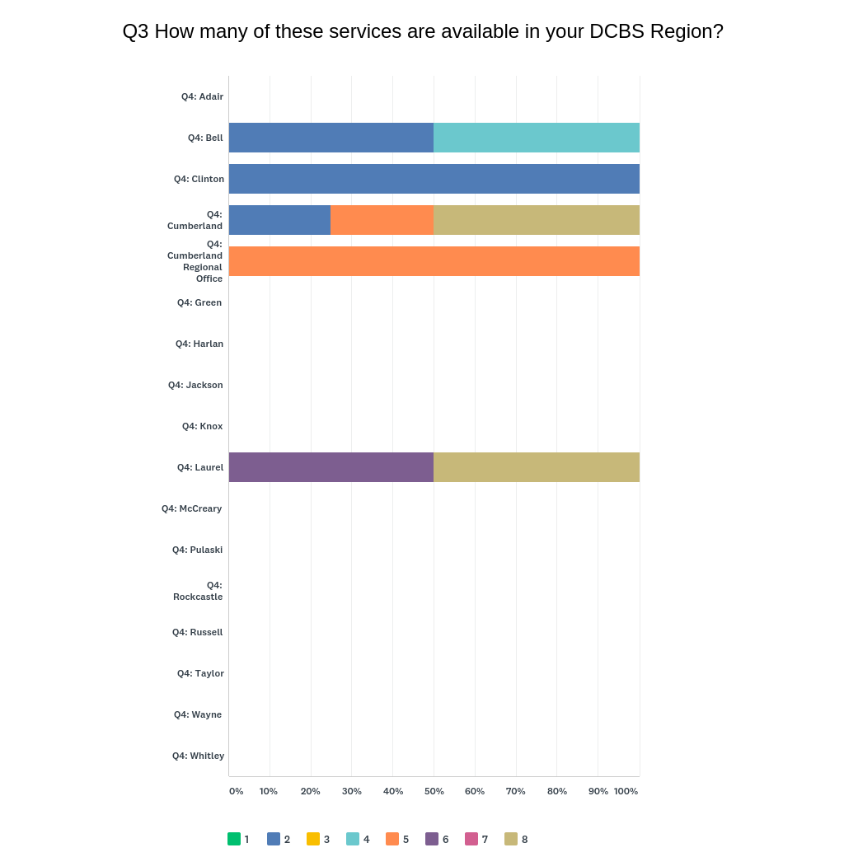

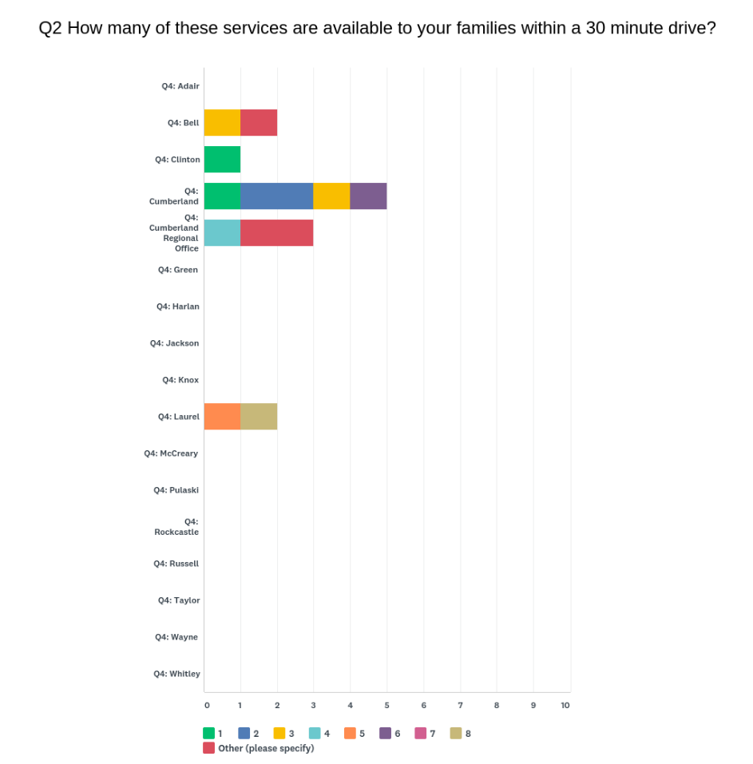

When you look at these graphs, why do you think there is such a discrepancy between respondent’s answers?