* **Attendance** – Please type your name and agency in the chat box.

|  |  |  |
| --- | --- | --- |
| Lena Morehead, DPP | Joy Varney, DBH | Carol Cecil, KPFC |
| Sherry Postlewaite, DPP | Tracy DeSimone, DPP | Sherri Staley, DMS |
| Katy Kirkland, UK HDI | Chithra, UK HDI | Chris Cordell, DCBS |
| Dyzz Cooper, KPFC | Ann Hollen, DMS | Beth Jordan, DBH |
| Katy Mullins, DCBS | Michelle Niehaus, DBH | Kelly Pullen, AETNA |
| Jennifer Warren, DCBS | Kate Wagoner, DBH | Jessica Brown, DCBS |
| Dee Dee Ward, DBH | Julie Horen-Easley, AETNA | Christa Bell, DCBS |
| Cat Jones, AETNA | Tiffany Mullis, DCBS |  |

* **Meeting with DCBS and DBHDID Commissioners –** Beth Jordan
  + Confirm support of co-location of Regional SOC Implementation Specialists in DCBS regional offices
  + Provide guidance on how to ensure alignment of the SOC FIVE disparity reduction strategies with those being undertaken by DCBS and DBHDID
  + Promote awareness among DMS and MCO staff of the critical need for HFW to be Kentucky’s primary approach to intensive care coordination and to be adequately and sustainably funded
  + Mitigate barriers to expansion of standardized behavioral health and trauma screening  and functional assessment for all children/youth with child welfare involvement (expand beyond OOHC population)
  + Agree to be spokespersons who will raise system-level issues identified through SOC FIVE implementation to the statewide SOC governing body (SIAC) and other interagency bodies
* **Focus on Equity -** Provide guidance on how to ensure alignment of the SOC FIVE disparity reduction strategies with those being undertaken by DCBS and DBHDID

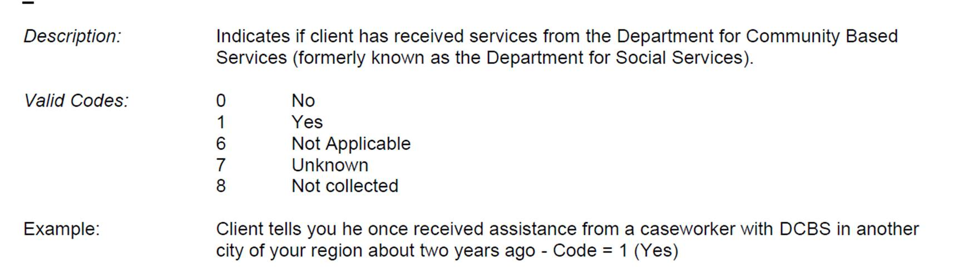

* + - Subcommittee: Carol, HDI Member, Katy or designee, Dyzz
  + Equity Sub Committee – we have DCBS data. What DBH data do we need?
  + Follow up with DCBS and DBH Commissioners Dec 11 with Rashaad, Jennifer W, Lesa Dennis, Tena, Beth, Dee Dee.
    - DBH Updates – Michelle N. – working on Dept wide racial equity plan. Youth satisfaction surveys, TAYLRD: unconscious and implicit bias trainings.
* **Cohort 1 RIAC Action Plan Updates –** 
  + Cumberland River
    - Purchased 500 flash drives to be filled with information and resources for target population. Nov meeting discussed what goes on flash drive and who to disseminate to. Plan to finalize list at next meeting.
  + Barren River
    - Discussed number of children at risk of removal and receiving in-home services by DCBS. Drugs are a common theme.
    - July: The RIAC used FY20 System of Care FIVE grant funds to purchase educational materials and safety items for the purpose of preventing out of home care to children of families with DCBS involvement. Safety items include bath thermometers, outlet covers, medication lockboxes, safety kits, first aid kits and smoke detectors. Educational materials include: Nighttime Interruptions, 10 Tips for Single Parents, 25 Ways to Praise, Baby Bottle Tooth Decay, Be There, Be a Dad, Bedtime Routines, Biting, Hitting, Hair Pulling, Disciplining Your Child, Feel Good About Yourself as a Parent, How to Deal with Your Baby’s Crying, Separation, Shaken Baby Syndrome, Temper Tantrums, The Importance of Attachment, What is a Good Parent? , Be the Best You Can Be, Never Shake a Baby, Ten Tips on Raising Kids
  + Lake Cumberland:
    - The RIAC used FY20 SOC FIVE grant funds to purchase safety coloring books, journals, first aid kits, stress balls, antibacterial wipes, hand sanitizers, games, outlet covers backpacks, and resources such as suicide prevention. These items will be sent to the DCBS offices and Case Managers and will be shared with clients.
    - Sept: all remaining bags were delivered to DCBS offices and case managers to provide to families within the target population. Hand sanitizers and outlet covers were added to the resource bags.
  + Green River:
    - Recently discussed DCBS Out of Home numbers.
* **Presentation: KY Supporting Kentucky’s Youth (SKY)**  - See PPT
  + Tiffany Mullis (DCBS)
  + Kelly Pullen (AETNA)
  + Cat Jones (AETNA)
* **Regional GMITs** – Katy M.
  + Screener & CANS for In-Home cases update:
    - Met w/ SRAs. Cumberland picked Pulaski INV team and Laurel INV team to begin roll out. TR picked 2 ongoing teams in Warren and Daviess. Learning opportunity to see which team is best suited. Determined screeners to be completed on all youth in the home with a sub or FINS. Cumb region will continue with OOHC Sp to continue w/ in-home screeners. TR region will have Prevention Sp. take on screeners.
    - BHSOs completing CANS. Can’t make non-CMHC complete CANS and NOMS data.
    - You can do TWIST screeners on in-home youth, it’s the TWIST push to KIDNET that isn’t there.
    - Tracking and ensuring compliance – need to work out.
    - Email to prep DCBS and CMHC for flow and decision.
    - Invite Chithra to R-GMIT meetings.
* **Evaluation Update– (**Dr. Chithra Adams)
  + New HDI Staff – Jessica Ware, Katy Kirkland, Mary Hajner
  + Completed year one reporting. Submitted year end requirements.
* **NOFO Updates** 
  + First Awards began Nov 1:
    - Lifeskills: HFW Program: Lifeskills will be adding 4 full time facilitators
    - Lifeskills: Respite Program: Begin Nov1. The focus will be on families involved with DCBS and children who are still in the home. Working with DCBS to finalize the referral process.
    - Uspiritus Intensive In-Home & Respite ready to begin Nov. 1.
  + NOFO 2.0 (2021)
    - Six new applications from 3 agencies. Reviewers assigned and plan to provide recommendation for next month’s SGMIT – Dec 4.
* **IMPORTANT DATES:**

|  |  |
| --- | --- |
| Optional Bidders’ Virtual Meeting | October 8th, 2020, 1PM Eastern Time |
| Required Letter of Intent/Evidence of Eligibility | October 16th, 2020 |
| Virtual Discussions Window | October 19th through October 23rd, 2020 |
| Application Window | November 5th through November 20th, 2020 |
| Application Due Date | November 20th, 2020, 8AM Eastern Time |
| Award Decision | December 4th, 2020 |
| Official Award Notice to Agencies |  |
| Contract Execution | February 1, 2021 |

* **Family and Youth Involvement –** Carol
  + PPT
  + Will send out Family and Youth Driven SOC Subcommittee invitations again.
* **Other – Previous Action Items:**
  + DCBS posted a position to head up anti-racism and has other activities in the works.
  + Action Item: subcommittee to plan ways GMIT can support DCBS focusing on access, use, and outcomes related to behavioral health services for CW population.
* **Agency Updates:**
* **Ideas for upcoming information sharing**
* **Next Meeting:** December 4th, 2020 1pm – Microsoft Teams
  + Approval of NOFO Awards