Goal of the Grant: to improve behavioral health outcomes for children and youth (birth through age 21) who meet criteria for SED and their families and who have child welfare involvement. For this project, child welfare-involved families are those for whom a child abuse and/or neglect investigation results in a substantiation or services-needed finding.
Purpose of the GMIT: interagency team responsible for management of the grant, oversight of state and local implementation activities, and ongoing communication with the system of care governing bodies.
Attendees
Dee Dee Ward | Lea Talyor | Michelle Sawyers
Maxine Reid | Mary Hajner | Amanda Metcalf
Shellie Mills | Denise Marlett | Jessica Ware
Kelvin Bailey | Debra Collins | Amanda Miller
Greta Baker | Kelly Minton | Monica Hoskins
Beth Jordan | Tammi Taylor | Joy Varney
Kelly Bradshaw | Tina Morrow | Lizzie Minton
Kelly Dorman | Vanessa Brewer | Leslie Hughes Burgess
Dyzz Cooper | Jill Edwards

  - November meeting is being moved to November 4, 2021

- Family & Youth Involvement: Regional GMIT Goal Summary - Implement strategies to promote and sustain the voice of children, youth, and their families with child welfare involvement at all levels of the system of care. (Practice, Program, Policy levels)
- Recruiting Family and Youth members:
Joy - Parent recruitment flyer has received a lot of responses.
- Joy didn’t have a good match with her responses, but they were interested in getting involved. Families are ready and willing, but some don’t realize that other opportunities are available.

Beth – some families and youth may not be ready for something like a RGMIT, but there are other opportunities for them to get involved.

- Please share the flyer, it can be found on the SOC FIVE website.
  - Some foot traffic came from flyers hung at Kings Island.
  - Members suggested other locations for flyers: resource rooms, bathroom doors, schools, lobbies, libraries, and county extension offices.

- Dyzz – There are many youth leadership opportunities.
- Discord – social media platform is being utilized by KYMOVE
  - Used in Indiana and youth participation increased by 60-70%.
- Starting youth cafes next month, starting youth leadership training in January at KPFC.
- Peers support specialists do a lot of outreach.

Kelly Minton – been in contact with Amanda on a prospective family representative in the leadership academy at KPFC.

Action Items | Person Responsible | Deadline

- SOC FIVE Racial Equity Team – Leslie Hughes Burgess & Kelly B.
Find notes, agendas & info on the SOC RET on the SOC FIVE website:
https://socv.hdiuky.net/grant-application-foa-files/?sf_tag=soc-five-racialequity

SOC FIVE Racial Equity Team (RET) will begin a monthly regional presence to facilitate discussions on regional racial and equity issues. Today’s discussion focused on the difference between equity and equality. Questions were asked via Slido poll to protect RGMIT member anonymity. Members shared an interest in learning more and participated in an open discussion.
Action Items | Person Responsible | Deadline

- Data & Evaluation – Jessica Ware
September CQI Metrics:
DCBS Data
- Policy Changes = 0
- Outreach = 240
- DCBS Screeners completed = 136
- Number of refusals/denials of the DCBS Screener = 13
- Referrals made for CANS = 31
- Number who did not screen in for the CANS = 80
- Number who refused/denied CANS = 7 (same as last month)
      - Number of outreach doubled (from 112 to 240)
      - DCBS screeners completed also doubled (from 66 to 136)
      - Number who did not screen in for the CANS 80 almost doubled from 42 to 80
Referrals made for CANS up from 19 to 31
      - denials of the DCBS Screener saw slight increase from 8 to 13
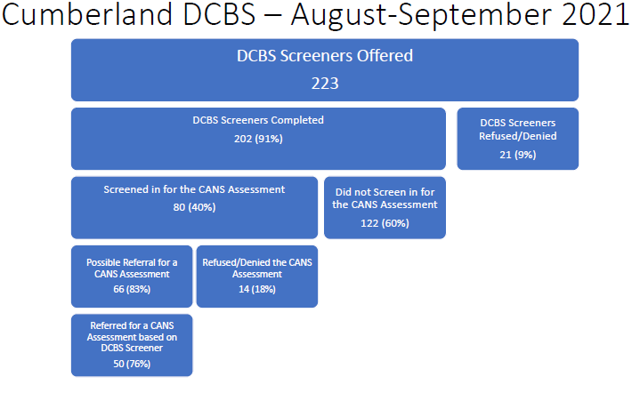
BHP Provider Data for August
- Number of Policy Changes = 1 Adanta, 2 CRBH
- Number of Outreach Efforts = 96 Adanta, 104 CRBH.
- Number of initial CANS completed = 0 Adanta, 3 CRBH
- Number not referred to services = 0 (both)
- Number of children/youth referred to services/treatment based on CANS = 0 Adanta, 3 CRBH
- Number of children/youth receiving services or treatment after referral – 0 Adanta, 3 CRBH
- Number of baseline NOMs completed – 0 from Adanta and 0 CRBH

Beth – glad to see numbers going up this month
Dee Dee – Asked if Cumberland screening was average for the group
Action Items | Person Responsible | Deadline

- Agency Updates
v SOC FIVE
- Welcome to Tammi and Kelly D.
- Partner Funding Request
  - CMHCs and RIACs in Cohorts 1 and 2 cannot apply, but other agencies in the region are eligible to apply.
- SOC Academy planning has started; will likely be virtual Spring 2022
v DCBS
- All counties are doing screeners
- CRVBH
- Grateful for staff that they have, staffing issues persist
- ADANTA
- Maintaining one assessor per county has been longstanding goal
- In November hoping to get more people trained in Nurturing Parenting
  - They have a lead on possible grant opportunity to expand Nurturing Parenting capacity.
- Outreach occurring at schools, handing out flyers and goodies.
- Staffing has not changed much either.
- KPFC
          - Core Competency Training this week
          - Presenting at the FRYSC Fall Institute
          - Smart Recovery and Nurturing Parenting training is expanding

- RIAC
- RIAC is growing- new youth rep out of Green County.
- Working on appointing new chairperson
- Handed out gift bags
- AOC
- Increasing numbers of kids in juvenile justice system, consistent with school starting (Schools are the primary referral source).

Action Items | Person Responsible | Deadline
NEXT MEETING: November 4, 2021 ZOOM Format
Please see SOC FIVE Internal Website for meeting notes: https://socv.hdiuky.net/

