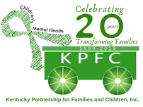

KPFC The Lakes Region Peer Support Center

Kayla Harmon- Family Peer Support Specialist

[kayla@kypartnership.org](mailto:kayla@kypartnership.org)

[referrals@kypartnership.org](mailto:referrals@kypartnership.org)

What we provide:

* Support Groups (Smart Recovery, Nurturing Parenting
* Leadership Opportunities
* Individual Peer Services
* Training Opportunities
* Consultation and Advocacy
* Family and Youth Peer Services
* Family events and resource navigation
* Fun, safe, and non-judgmental environment

Counties we serve: Ballard, Caldwell, Calloway, Carlisle, Christian, Crittenden, Fulton, Graves, Hickman, Hopkins, Livingston, Lyon, Marshall, McCracken, Muhlenberg, Todd, and Trigg.