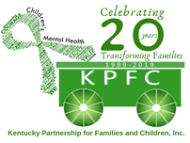

KPFC Two Rivers Peer Support Center

Gayla Lockhart- Family Peer Support Specialist

gayla@kypartnership.org

Erix Delgado- Youth Peer Support Specialist

erix@kypartnership.org

[referrals@kypartnership.org](mailto:referrals@kypartnership.org)

What we provide:

* Support Groups (Smart Recovery, Nurturing Parenting
* Leadership Opportunities
* Individual Peer Services
* Training Opportunities
* Consultation and Advocacy
* Family and Youth Peer Services
* Family events and resource navigation
* Fun, safe, and non-judgmental environment

Counties we serve: Allen, Barren, Butler, Daviess, Edmonson, Hancock, McLean, Metcalfe, Monroe, Ohio, Hart, Henderson, Logan, Simpson, Union, Warren, and Webster.