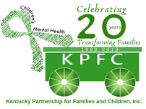

KPFC Salt River Trail Region Peer Support Center

Kerry Goodman- Family Peer Support Specialist

Deanna Frazer- Family Peer Support Specialist

[kerry@kypartnership.org](mailto:kerry@kypartnership.org)

[deanna@kypartnership.org](mailto:deanna@kypartnership.org)

What we provide:

* Support Groups (Smart Recovery, Nurturing Parenting
* Leadership Opportunities
* Individual Peer Services
* Training Opportunities
* Consultation and Advocacy
* Family and Youth Peer Services
* Family events and resource navigation
* Fun, safe, and non-judgmental environment

Counties we serve: Anderson, Breckinridge, Bullitt, Franklin, Grayson, Hardin, Shelby, Spencer, Trimble, Washington, Woodford, Henry, Larue, Marion, Meade, Nelson, and Oldham.