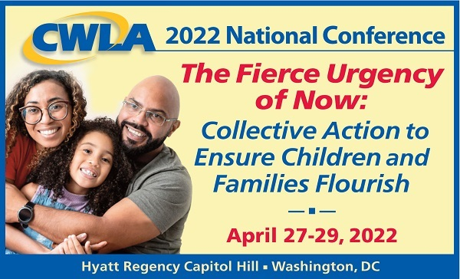

Join us for the **CWLA** **2022 National Conference,*The Fierce Urgency of Now: Collective Action to Ensure Children and Families Flourish****,*scheduled to be held at the Hyatt Regency Capitol Hill in Washington, DC, from April 27-29, 2022.

Click the link below to register!

[CWLA 2022 National Conference – CWLA](https://www.cwla.org/cwla2022/)

We are living in challenging times. There is a fierce sense of urgency and demand for institutions to make bold changes to better serve all children and families, especially those who are Black, Brown, and Indigenous. Child welfare is not exempt from these calls for change. As professionals and volunteers working in a high-stakes field, we have learned from the events of this past year that we can and must do business differently. We need to find bold ways to make the type of changes required to reach the vision of CWLA’s *National Blueprint for Excellence in Child Welfare (National Blueprint)* “that all children will grow up safely, in families who are loving, with everything they need to flourish – and with connections to their culture, ethnicity, race, and language.”

But child welfare cannot do this alone. We need to collectively work hand-in-hand with families, communities, and other systems, as well as federal, state, and local leadership, to eliminate the many barriers to achieving our vision. The 2022 CWLA conference will be an opportunity to use our 4 A’s approach for transformation: awareness, acknowledgment, action, and accountability. We look forward to welcoming back our friends, colleagues, and partners – old and new – to connect, reconnect, recharge, and make decisions about how we collectively and as individuals, agencies, the child welfare system, and society as a whole can and must take action to achieve a better world for all children and families.

Using the 4 A’s framework for transformation and the *National Blueprint*, the conference will create awareness; acknowledge where we have not gotten it right; highlight successful strategies, research, practices, advocacy, and actions that individuals, families, organizations, and communities are using to improve supports and services; and identify what we will collectively do as part of our accountability to address today’s critical child welfare issues.

As we again come together in-person, everyone’s health and well-being are our first priorities. The conference planning committee has formed a special Safety Subcommittee and we will be working in partnership with the Hyatt Regency Capitol Hill to ensure that all necessary protections and protocols are in place.

For the first time since 2019, CWLA looks forward to utilizing our connections with and access to Congress, the Administration, and other national coalitions and organizations to provide you with opportunities to dialogue with these important stakeholders. Our traditional Advocacy Day activities may look different due to possible restrictions on Capitol Hill, but we will be sure to incorporate opportunities for your voice to be heard on the critical issues of Child Tax Credit (CTC) extension, implementation of childcare expansion, and many more significant topics.

We have planned a fast-paced conference that will feature plenary sessions, a panel presentation, and 60-minute Action Labs, which will draw on the experiences of your public and private peers in child welfare and related service areas; our research, advocacy, and education partners; and representatives from families and communities. The sessions will present evidence-informed/evidence-based programs and practices, research, and projects focused on topics related to implementation of the Family First Prevention Services Act, cross-system collaboration, youth engagement, kinship navigation, advancing equity, prevention and intervention, workforce supports, managing organizational change, community partnerships, and much more. Having been apart for so long, we will also provide ample opportunities for networking and reconnecting with friends and colleagues from across the country.

Also, you will have opportunities during the conference to provide input into what CWLA includes as we update the current *Standards of Excellence for Child Protective Services* and create a new *Standards of Excellence for Community-Based Prevention Services.* Come hear about what CWLA is doing and contribute your wisdom to our final product!

As always, the conference is an excellent opportunity for all of us to recommit to our collective work and advocacy to advance quality services and a continuum of care, create communities of support, and take action to ensure that all children and families flourish. We look forward to seeing you in Washington, DC!

Contact us at [CWLA2022@cwla.org](mailto:CWLA2022@cwla.org) for assistance.