# Attendees

**Goal of the Grant:** to improve behavioral health outcomes for children and youth (birth through age 21) who meet criteria for SED and their families and who have child welfare involvement. For this project, child welfare-involved families are those for whom a child abuse and/or neglect investigation results in a substantiation or services-needed finding.

**Purpose of the GMIT:** interagency team responsible for management of the grant, oversight of state and local implementation activities, and ongoing communication with the system of care governing bodies.

|  |  |  |  |  |  |  |  |
| --- | --- | --- | --- | --- | --- | --- | --- |
|  | Amanda Metcalf |  | Jennifer Warren |  | Leslie Hughes Burgess |  | Tracy DeSimone |
|  | Barb Greene |  | Jenny Thornhill |  | Lizzie Minton |  | Tevis Duncan |
|  | Chris Cordell |  | Jessica Ware |  | Mary Carpenter |  | Vestena Robbins |
|  | Beth Jordan |  | Josh Swetnam |  | Michelle Niehaus |  |  |
|  | Carmilla Ratliff |  | Kenneth Fletcher |  | Maxine Reid |  |  |
|  | Carol Cecil |  | Joy Varney |  | Melinda Vise |  |  |
|  | Clarissa Allen |  | Kate Overberg Wagoner |  | Micah Blevins |  |  |
|  | Dakota Simmons |  | Katie Kirkland |  | Michelle Sawyers |  |  |
|  | David Lohr |  | Katy Mullins |  | Randa Bush |  |  |
|  | Dee Dee Ward |  | Kelli Root |  | Sherri Staley |  |  |
|  | Demarco Harris |  | Kelly Bradshaw |  |  |  |  |
|  | Dyzz Cooper |  | Kelly Dorman |  | Tammi Taylor |  |  |

= Present  = Absent

# Welcome and Introductions

Dee Dee welcomed new members and the team introduced themselves and how they support the project.

# Partner Funding Awardee: Worth the Words, Demarco Harris

Nonprofit utilizing music technology and other creative mediums to help youth process their trauma while learning transferable skills; partners with Jefferson County Public Schools to offer 6–8-week workshop opportunities for students.

**Need**

* Lack of access and or extracurricular programming offered to youth in underserved communities and school systems

**Goals**

* Increase access to music technology
* Develop emotional intelligence and increase ability to identify coping mechanisms
* Increase self-esteem/self-efficacy

**Stakeholders**

* Initial board members community partners; The Spot ([The Spot - Young Adult Opportunity Campus (thespotky.org)](https://www.thespotky.org/)
* Louisville Central Community Center ([Home | LCCC (lcccnews.org)](http://www.lcccnews.org/))

**In kind Contributions**

* Volunteer Instruction Time, Volunteer Operational Management Time, Instructional Spaces

**Summary and Evaluation**

* Utilize post surveys for evaluation effectiveness upon completion & completion projects upon programming completion

The group is mobile and can travel to implement programing. Members suggested TAYLRD as an ideal partnering opportunity and exchanged contact information.

Contact information: Demarco Harris, [demarcoharrisllc@gmail.com](mailto:demarcoharrisllc@gmail.com)

## July Cycle Funding Summary, Maxine Reid

* 19 applications were approved over the last two years with a total funding amount of $119,000.
* The latest round was only able to fund 12 at $54,000. No more funding at this time.
* Applications came from all over the state
* Maxine will provide a full overview next month. Dee Dee thanked Maxine and Carmilla for all their hard work promoting and processing applications.

## Action Items

Task Description Person Responsible Deadline

Provide Full Overview Maxine Oct 2022

# Quarterly Data Update, UK HDI & Implementation Specialists

Katie presented an update on the SOC FIVE Services Intervention Pathway—reporting on Continuous Quality Improvement (CQI) data and numbers of baseline NOMs (National Outcome Measures). The presentation focused on monthly averages for the past quarter (April-June 2022). As shown in the below table, for each metric, the monthly average for All Regions exceeds the grant’s Model. (All Regions is the sum of each region’s data.)

**SERVICES INTERVENTION PATHWAY MONTHLY AVERAGES – APRIL-JUNE 2022**



*Notes: Averages reported above are rounded to the nearest tenth.*

*Green shading indicates a number or percentage above the Model and orange shading indicates a number or percentage below the Model.*

Cumulative totals from October 2020-June 2022 were also reported. These are shown in the below table.

**SERVICES INTERVENTION PATHWAY   
CUMULATIVE TOTALS – OCTOBER 2020-JUNE 2022**

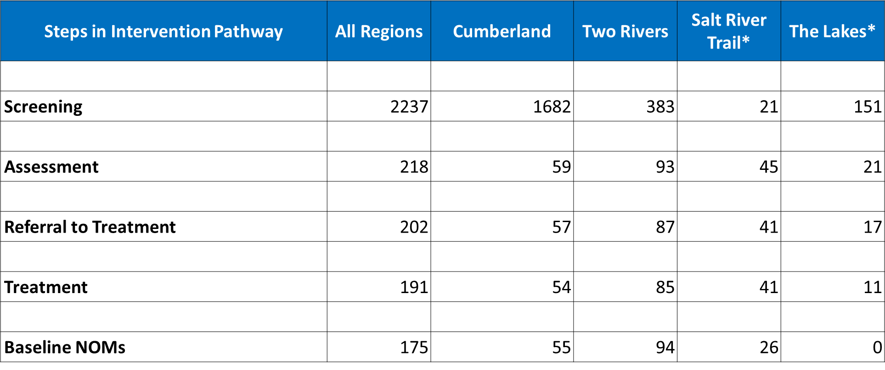

*\*Note: In Cohort 2, DCBS screeners started in January 2002 in The Lakes region and in March 2022 in the Salt River Trail region.*

* Salt River Trail has been looking to increase screeners. Kelly D. created an infographic with a condensed Services Intervention Pathway to assist her region.
* Cumberland has a new high fidelity wraparound provider. Transportation and lack of out of school activities are barriers for the region. Regional GMIT team members noted a current need for youth substance abuse services.
* Lakes region providers have completed some NOMs, working on getting assessments, some providers are still hiring staff for services; expecting numbers to pick up
* Two Rivers has made a lot of progress as well, services are picking up in the region.
* All regions are utilizing screener brochure

Medicaid representative, Sherri Staley, explained that the regulations have expanded to include policy changes that occurred over the pandemic; anything listed as ‘face to face’ is now applicable to video conferences.

## Action Items

Task Description Person Responsible Deadline

N/A

# SIAC Recommendation & Agency Updates

SIAC Recommendation

* Since no action was taken on the previous recommendation, aside from the formation of the ad hoc workgroup, this group could consider revising last year’s recommendation.

KPFC

* KPFC has 3 staff members working in Eastern KY to provide disaster relief
* Started First Friday webinars (free webinars on the first Friday of every month from 10-12 p.m.)
* Family and peer support training coming up in October
* Youth empowerment coordinator
* Leadership Academy being held virtually for youth in 3-4 DJJ facilities
* LEAD KY is still meeting and providing data
* KPFC Cafés first Thursday of every month not getting many registered, please share with others

All events are on the webpage: <https://kypartnership.org/events/>

DBHDID

* The Department has not changed, the only change is the ‘Division of Mental Health’ There are three branches under the Division, two of the branches are the same, one is new. The change will reduce burden on staff and make grant designation easier.
* Kate Overberg Wagoner accepted a new role on Beth Jordan’s team as the Youth Substance Use Program Coordinator

DCBS

* Child Protection Branch are splitting off into their own division and a Division of Prevention will be created; more updates will be provided as they become available.

Provider

* Boys and Girls Haven has been able to add two new community support staff under Medicaid services; these staff will support SOC families.

**Next Meeting:** September 9, 2022,via Zoom: [State GMIT Meeting](https://us02web.zoom.us/j/82154195143?pwd=anYrVjlJRXQ4ejgxaDRYeDFCQ0IrUT09)

**Notes:** [Kentucky System of Care V – Improving Outcomes for Children, Youth, and Young Adults with Mental Health Challenges and their Families (hdiuky.net)](https://socv.hdiuky.net/)